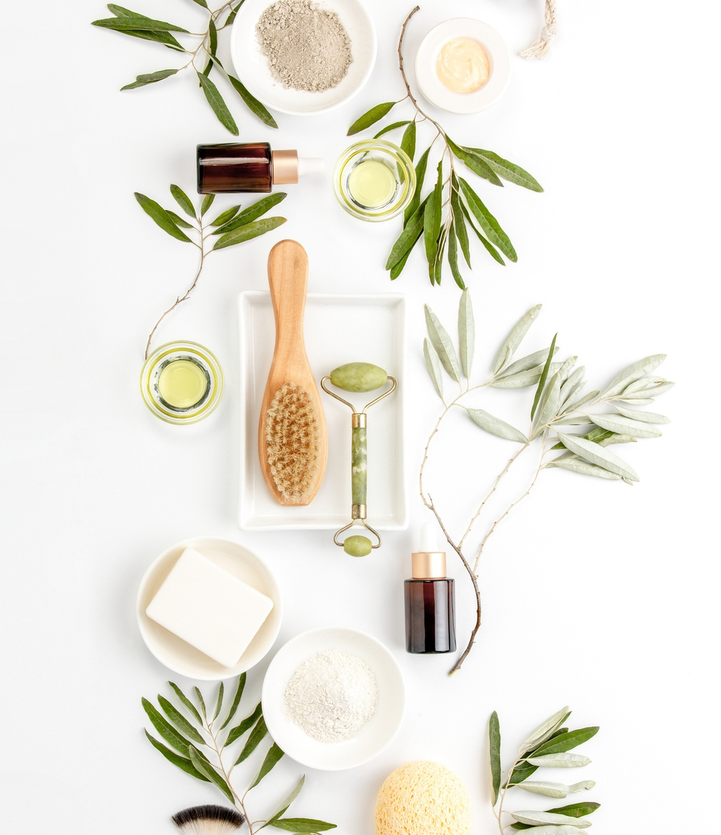  Project Plan Template  Knowledge Based Recommendation System | Taniya Adhikari  DSC 630  June 05, 2021

Table of Contents
1 Executive Summary 2
2 Intro/Background 2
3 Methods 3
4 Results 4
5 Discussions/Conclusion 6
6 Acknowledgements 6
7 References 6

EXECUTIVE SUMMARY
This project focuses on building a knowledge-based recommendation system for skincare products based on user preferences. The motivation of this project is to make consumer shopping experience quick and easy by successfully recommending top products from the wide variety of products available in the market. Consumers of skincare products are often faced with huge challenge of choosing from variety of options. In this project I attempted to develop a system that uses predictive analytics to recommend products to users by matching them to highly rated products and similar users. The recommendation system is an interactive tool, that will be asking user to give their preferences and it will recommend products by finding products that are highly satisfying to customers as well as how closely user matches to the customers who had similar issues or problems.
For this type of recommendation system, I will be collecting data from sokoglam.com. It is in e-commerce website for Korean beauty products. I will be using product reviews from this website for each product and perform sentiment analysis to find the products that are highly satisfying and then matching it with user preference data. For this project, I narrowed down products to only k-beauty brands (Korean skincare) because they are new to global market and has been quite successful in recent years and it has a small pool of skincare products, so it becomes easier to analyze the data.
In this project, the algorithm shows the top 2 or 3 products based on sentiment of the products reviews and similarity to the user inputs. Though, it predicts the sentiment of the reviews, it is a textual data, so there are some uncertainties with the results. It is also matching products to users based on predefined user inputs and product reviews. This was a result of having unlabelled data, and thus it requires further developments.

INTRO/BACKGROUND
For the longest time beauty and personal care industry has been ruled by the legacy brands or the brands that are easily available on the store. However, in recent years industry has shifted towards ecommerce, due to this there has been a rapid growth in the industry which led to increase in newer brands with more options in skincare products. We are introduced with different types of skincare products from all over the world and countries like Korea, Japan, and India. There are ten thousand plus beauty products out there and new products add on daily basis which makes it hard for consumers to choose from. The purpose of this project is to build a tool to find top skincare products for specific skin concerns and suggest products to the user based on user query.
The problem with a vast variety of skincare products is that consumers are burdened with a challenge of choosing from numerous products, which is often time consuming and difficult to select the right product for their skin concerns. Usually, consumer will look up reviews for products to find the best match, however, overflowing reviews online becomes overwhelming and consumer must read through reviews to find products. In this project, I attempt to find a solution of this problem by developing a knowledge-based recommendation system that takes user preferences and match it with the top products based on sentiment of reviews.
However, it is unstructured data and there is no specific target variable. Therefore, I will be doing unsupervised learning and combining it with predictive analytics. I will be performing similarity and sentiment analysis; thus, I will be calculating scores for those two. First, I will be finding sentiment score for reviews online, then I will be finding similarity score between the user preference and reviews to find the product that is used by similar customer.

METHODS
Data Understanding and Preparation

The data required for this project is list of products and its reviews. There was no available dataset for this project, thus for data collection step, I scraped data from SokoGlam.com. There are two reasons for this seller website: 1.) It specializes in Korean beauty products. Most Korean beauty products are highly rated and are known to be quite effective. 2.) It has a smaller product list and variety with fewer brands. From data collection standpoint, this was optimal choice. I created two datasets, one with product list and one with product reviews. Some of the variables for this project is product name, product brand, product type, product description, price, product id, and product reviews. The first step I did was get product information, product id and product name and converted that into dataset, then using product id, I retrieved reviews for each product. Furthermore, I removed any item that does not fall into skincare products and removed reviews that are replies from a seller to customers. (See Appendix for Data Collection Code)
For text analysis, I pre-processed reviews and product description data by turning all texts into all lowercase and removing all punctuations. A common challenge with large text data is that corpus contains large vocabulary. To reduce number of words, I removed stop words and performed lemmatization. I created two dataset one for product list that had all the product information and one for product reviews. All the pre-processing was done so text data can be used for model development. (See Appendix for Data Preparation Code)
After Data preparation I performed some exploratory data analysis for each dataset. Most of the data was text or categorical data that required little initial analysis, but there were some variables that gives valuable information about the data. No missing value analysis were performed, because during data collection step, all the missing values were already filtered. (See Appendix for EDA Code)
Here are the results of exploratory analysis:
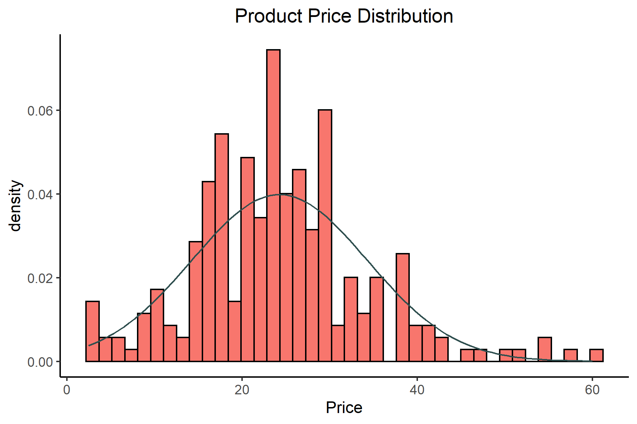
Price range falls between $2.5 to $60.
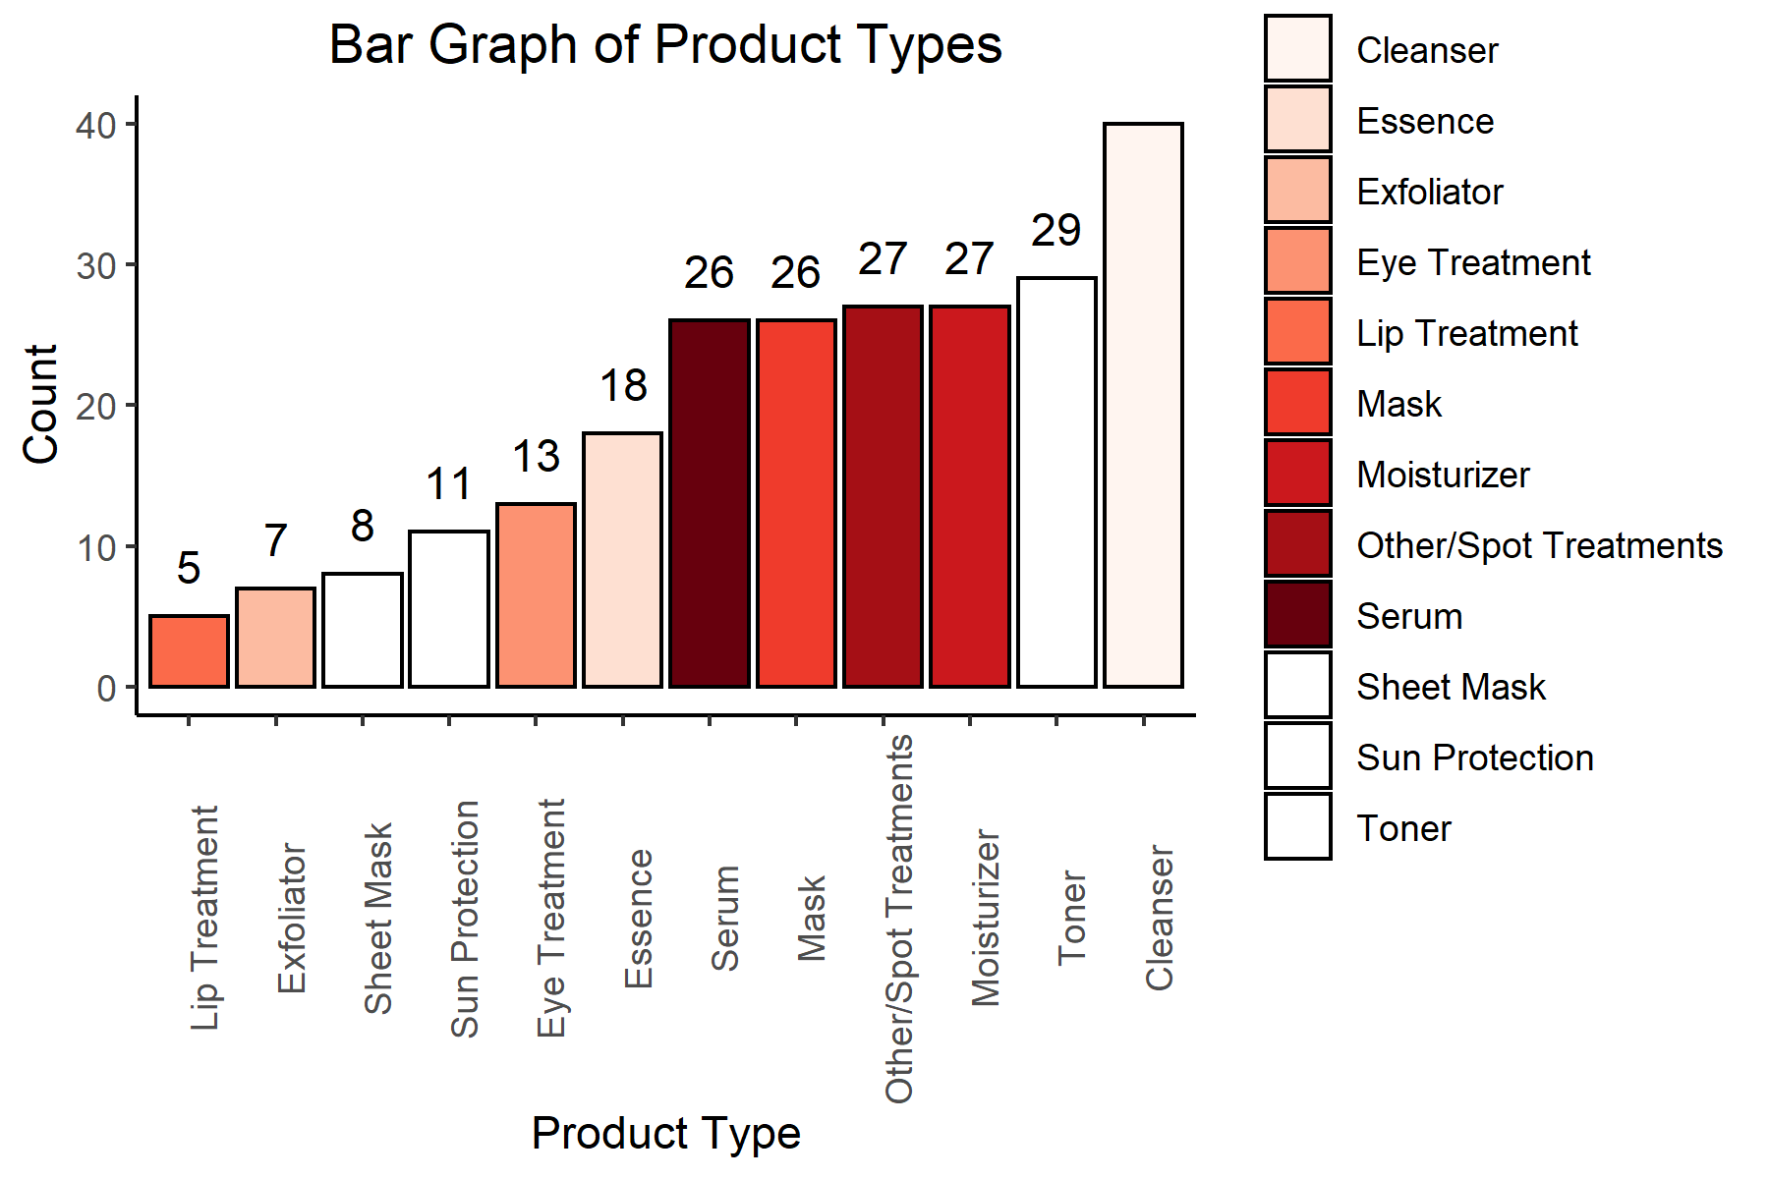
There are 12 types of products that I gathered from SokoGlam (this includes only skin care items). It appears product types are imbalanced and cleanser category had the highest number of products.
Furthermore, I performed analysis for fake reviews. This was done with the assumption that fake reviews are usually copy paste reviews with same words, so I looked for reviews with 80% similarity. To do this I looked for most common words in the reviews and used term frequency-inverse document frequency (TF-IDF) and cosine similarity. I kept the original review intact for further sentiment analysis. I attempted to do some fuzzy matching to find words that could be spelling mistakes, but it was not a success when I combined it with BOW model (Note: more analysis is needed on this one). Below is the most common words appeared in the product reviews. (See Appendix for EDA Code)
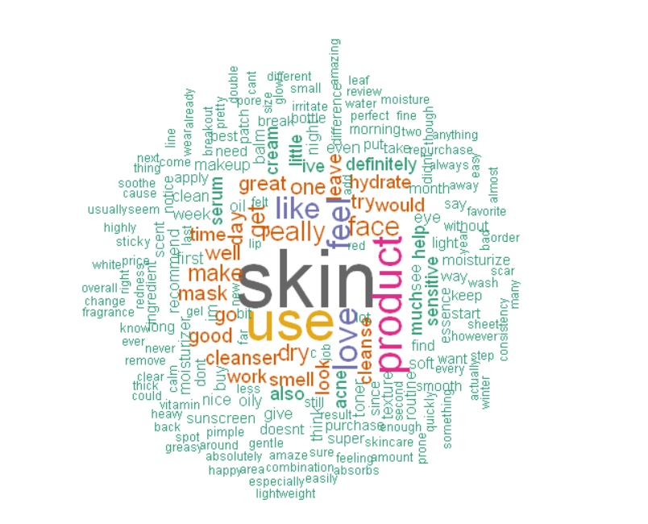
Most Frequent Words in Product Reviews
(See Appendix for Graphs and Visuals Code)
Modelling
For knowledge-based recommendation system, I had to use a different approach. Since it is slightly different from collaborative and content-based recommendation. I did not have user history to recommend product, instead I was using user input to recommend top products. All the reviews were unlabelled text data, with unknown sentiment. Thus, supervised learning was not ideal choice for this sentiment analysis.


Visual Representation of Modelling Algorithm
Top Products Based on User Sentiments’
User
Preferences
Recommended Products
Inputs
Similar Products

Sentiment Analysis
The first step for this type of analysis was to get sentiment score for each review. I used nltk VADAR sentiment Analyzer to do unsupervised sentiment analysis on the reviews. VADAR sentiment analyzer is among the top tool to predict sentiment on unlabelled text data. It is a pre-trained model that requires little pre-processing of the text, but pre-processing was done to the reviews data.
Extracting Features for User Inputs
Second step involved extracting product features from the product reviews to it can be used for user preferences and similarity analysis. For this step I created Bag of Words model to turn reviews into matrix of features. Each review was turned into vector of features where 1 means the feature or word exist in the review and 0 means it is not in the review.
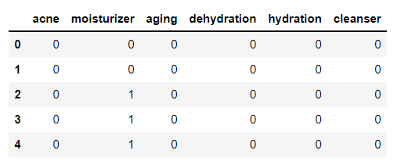
User preferences were chosen from the most common words associated with the products in the reviews combined with information from seller’s website. Since, it was pre-defined list, skin type, product types and price were already chosen from the dataset of product list for skin concerns and skin goals, these features were picked from BOW model above. These user inputs were stored in the list and then turned into vector to do similarity analysis with the reviews. Furthermore, user preferences were turned into jupyter notebook checkboxes using ipywidgets tool. User will simply enter their preference and submit it and it will generate results. (See Appendix for User Input lists)
Similarity Analysis
Fourth, similarity scores were calculated between user inputs and the reviews using cosine similarity. To recommend product, both similarity score and sentiment score were used. Weighted sum of average similarity score and average sentiment score for each product were used to find the top product. (See Appendix for Modelling Code)

RESULTS
To see model performance, I tested it with pseudo user inputs to check accuracy. (See Appendix for User Input lists)
User Input 1
Product-Type: Cleanser and Mask
Skin-Type: Oily
Skin-Concern: aging, clogged pore, hyper pigmentation
Skin-Goals: unclog pore, minimize pore, reduce wrinkles, hydration, smooth skin.
Price range: $2.5 - $46
Results 1
All three products match with the inputs with the high ratings (I manually checked this through Sokoglam website). However, the similarity score is quite low for the products.
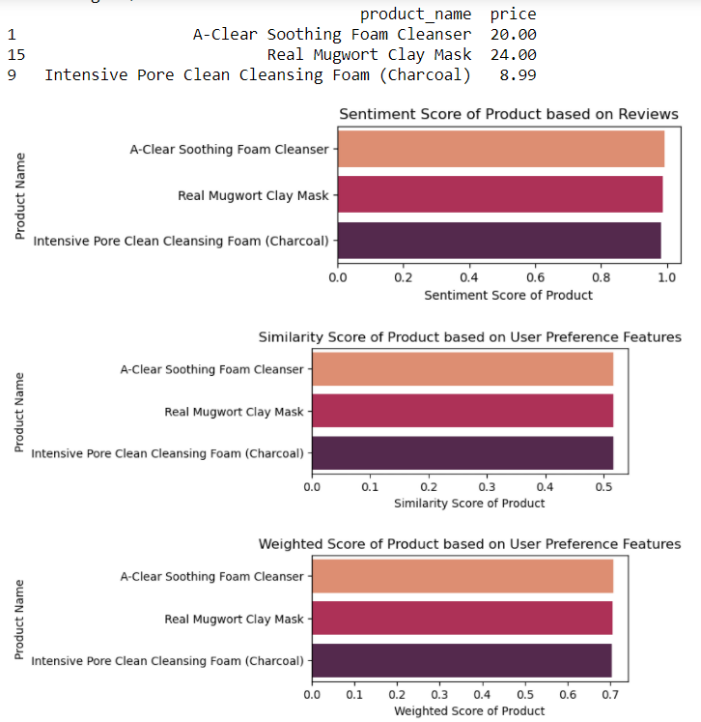
User Input 2
Product-Type: Toner and Moisturizer
Skin-Type: Oily
Skin-Concern: aging, dehydration, hyper pigmentation
Skin-Goals: reduce wrinkles, remove blackheads, remove dark spots, improve skin texture, hydration, smooth skin.
Price range: $2.5 - $46
Results 2
The first two products matched the user inputs (checked on sokoglam website). Third product was not so favourable because it had less similarity score, and it is a wrong product type.
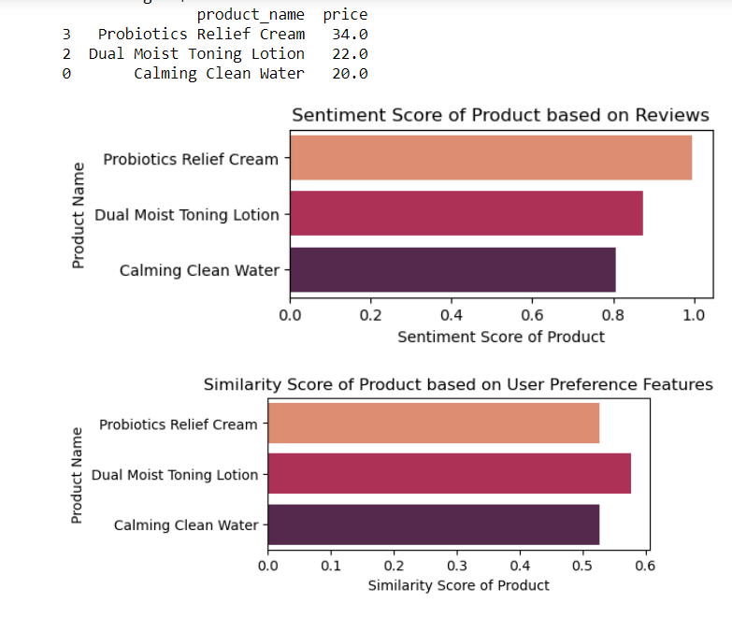
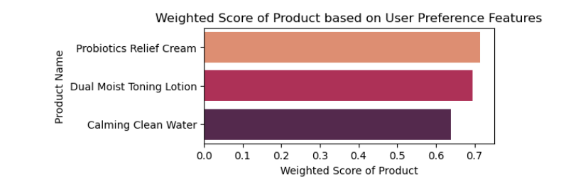

DISCUSSION/CONCLUSION
As I was working on the project, I realized that I was only applying predictive analytics to predict sentiment of reviews. There are lot of uncertainties with the unlabeled text data. Although, VADAR sentiment analyzer is the most sophisticated tool for unsupervised sentiment prediction, evaluation of the results is quite difficult. I believe, this model can be better with more data availability such as user transaction history or user search history. Most sellers such as amazon usually has that type of data available. For the business problem specified in this project, I believe it provides products that are similar with high sentiment, however, evaluating it is difficult and requires manual evaluation. There were other challenges regarding similarity analysis, because cosine similarity was used for matching user inputs with reviews, the model only performs as good as it matches words from user preference to words from the review. If it misses the word, then the results could be deceiving. This is the major issue with NLP analysis, there could be words with spelling mistakes, or synonyms, which should be included in similarity, but can be left out if not corrected carefully. I believe model performance can get better if these things were considered. Furthermore, this model can be combined with other types of recommendation system to solve a problem of “cold start” which is not knowing user history. This can also convert into product rating tool. I intend to continue this project and turn this into a web application as a skin care rating tool. Similar kind of model can be used for different products as well, so I plan on solidifying the algorithm.

ACKNOWLEDGEMENTS
I would like to thank my husband Bibek Adhikari and my friend Mayur Nag for helping me with data scraping and providing insights in this subject. If it not for them, I would have not been able to create a dataset for this project, due to difficulties on the website without pagination. I would also like to thank Brett Sutow, for providing his peer review and encouraging me for this project.

APPENDIX
Following files are added in the folder:
- User Preference list: Final_Project-User Inputs.pdf
- Data Collection Code File: Final_Project-Data Collection.pdf
- Data Preparation: Final_Project-Data Preparation.pdf
- EDA: Final_Project-EDA.pdf
- Graphs and Visuals: Final_Project-Graphs and Visuals_usingR.pdf
- Modeling: Final_Project-Unsupervised Modeling.pdf
- All Code files are also added in the folder.

REFERENCES
- Soko Glam - Korean Skin Care, Beauty & Makeup Products. (n.d.). Retrieved March 28, 2021, from https://www.sokoglam.com/.
- Roberts, R. (2021, March 08). 2021 beauty industry trends & Cosmetics Marketing: Statistics and strategies for your ecommerce growth. Retrieved March 28, 2021, from https://commonthreadco.com/blogs/coachs-corner/beauty-industry-cosmetics-marketing-ecommerce#:~:text=How%20big%20is%20the%20beauty,exceed%20%24716B%20by%202025.
- Sabanoglu, T. (2021, February 16). Cosmetic industry growth. Retrieved March 28, 2021, from https://www.statista.com/statistics/297070/growth-rate-of-the-global-cosmetics-market/
- Yalçın, O. G. (2021, February 2). Sentiment Analysis in 10 Minutes with Rule-Based VADER and NLTK. Medium. https://towardsdatascience.com/sentiment-analysis-in-10-minutes-with-rule-based-vader-and-nltk-72067970fb71.
- Zhang, K. (n.d.). How to Detect Fake Online Reviews using Machine Learning. ScoreData. https://scoredata.com/how-to-detect-fake-online-reviews-using-machine-learning-2/.

